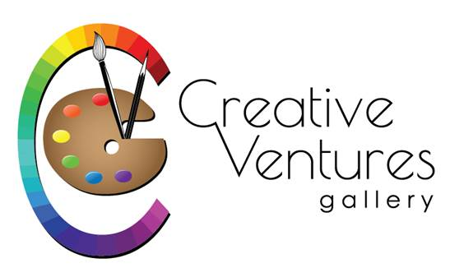“2022 Small Works – BIG IMPACT” at Creative Ventures
Gallery, 411 Nashua Street, Milford, NH 03055 - 603 672-2500
Artist_____________________________________________________
Address____________________________________________________
Town, state, zip_____________________________________________
Phone______________ Email__________________________________
Title______________________
Medium________________________
Price___________________________
Title_______________________
Medium________________________
Price__________________________
Title_____________________
Medium______________________
Price________________________

Keep the bottom for your reference but send the above info along with your check in the mail to the above address or pay on our website and send this info with your pictures and artist statement in an email to betsy@creativeventuresfineart.com

- This is an Open show for local artists
- This year the show will hang in the CV gallery walls. The reception will be on Nov 11th from 6-8pm. Bringing refreshments is optional. Masks are optional.
- ***Anything hung at CVG should not be listed with anyone else for the duration or it should be very clear that the customer needs to go through CV to purchase the item.
- Registration and money are due by Oct 23.
- Delivery is on Oct 28 (9-4), Oct 29 (10-2), and Oct 30 (9-4).
- Show dates are from November 1 to December 31
- Pick up dates are January 3-7 from 9am to the posted closing times.
- Outside dimensions of artwork are limited to 12” in any direction and must be ready to hang with wire.
- No nudes, photography or jewelry for this show
- Original works including but not limited to oil, watercolor, fiber, acrylic, pastel, drawing, color pencil, hand-pulled prints, mixed media, sculpture, wood, and pottery
- $10 for one piece ($15 for two or $20 for three) - pay with Paypal, mail check or phone
- All work must be for sale. Artist/Gallery split will be 75/25.
- Entry fees are used for paid advertisements.
- Send family, friends, and customers to view show at CVG at https://www.creativeventuresfineart.com/product-category/small-works-show/
- Don’t see your medium listed? – call us – 603-672-2500

