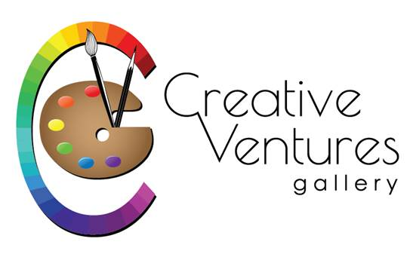“2021 Small Works – BIG IMPACT” at Creative Ventures
Gallery, 411 Nashua Street, Milford, NH 03055 - 603 672-2500
Artist_____________________________________________________
Address____________________________________________________
Town, state, zip_____________________________________________
Phone______________ Email__________________________________
Title______________________
Medium________________________
Price___________________________
Title_______________________
Medium________________________
Price__________________________
Title_____________________
Medium______________________
Price________________________

Keep the bottom for your reference but send the above info along with your check in the mail to the above address or pay online and send this info with your images with your artist statement in an email to betsy@creativeventuresfineart.com
- This is an Open show for local artists
- This year the show will hang in the CV gallery. The reception will be on Nov 12th from 6-8pm. Please bring individual servings of food (served in cups?). Masks are required.
- Anything listed with CV should not be listed with anyone else for the duration or it should be very clear that they need to go through CV to purchase the item.
- Registration and money are due by Oct 23.
- Delivery is on Oct 29 (9-4), Oct 30 (10-2), and Oct 31 (9-4).
- Show dates are from November 2 to December 31
- Pick up dates are January 4-9 from 9am to the posted closing times.
- Outside dimensions of artwork are limited to 13” in any direction and must be ready to hang with wire.
- No nudes, photography or jewelry for this show
- Original works including but not limited to oil, watercolor, fiber, acrylic, pastel, drawing, color pencil, hand-pulled prints, mixed media, sculpture, wood, pottery
- $10 for one piece ($15 for two or $20 for three) - pay with Paypal, mail check or thru phone
- All work must be for sale. Artist/Gallery split will be 75/25.
- NEW - If the work is sold online, you will get an email from CV and the artist is responsible for picking up the work from CV and shipping to the customer.
- Send family, friends, and customers to view show at CVG or https://www.creativeventuresfineart.com/product-category/small-works-show/
- Don’t see your medium listed? – call us – 603-672-2500

