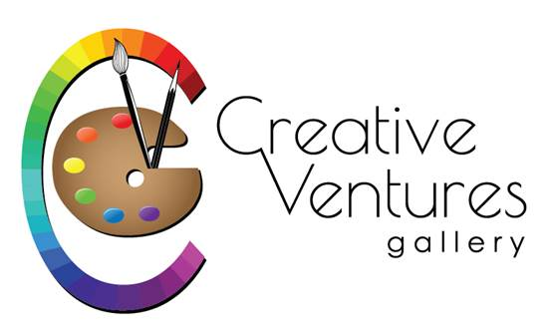“2020 Small Works – BIG IMPACT” at Creative Ventures
Gallery, 411 Nashua Street, Milford, NH 03055 - 603 672-2500
Artist_____________________________________________________
Address____________________________________________________
Town, state, zip_____________________________________________
Phone______________ Email__________________________________
Title_____________________________
Medium_______________________
Price________________________
Outside size__________________
Image size___________________
Title__________________________
Medium______________________
Price________________________
Outside size___________________
Image size____________________
Title_________________________
Medium______________________
Price_________________________
Outside size___________________
Image size___________________
Keep this for your reference but send the above info along with your images and artist statement attached in an email to betsy@creativeventuresfineart.com

- This is an Open show for local artists
- This year the show will be virtual and there will be no reception due to Covid.
- Show dates are from November 1 to December 31
- Outside dimensions of frame are limited to 12” in any direction
- No nudes, photography or jewelry for this show
- Original works including but not limited to oil, watercolor, fiber, acrylic, pastel, drawing, color pencil, hand-pulled prints, mixed media, sculpture, wood
- $10 for one piece ($15 for two or $20 for three) - pay with Paypal, mail check or phonecall
- All work must be for sale. Artist/Gallery split will be 75/25.
- Artists will be responsible for shipping. Incorporate that onto your prices.
- Registration and money are due by Oct 23.
- All artist statements to be emailed to CVG (see above address).
- Send family, friends, and customers to view show at https://www.creativeventuresfineart.com/small-works-big-impact-show/
- Don’t see your medium listed? – call us – 603-672-2500

